**Assignment -3**

Python Programming

**Question-1:**

Write a python code for blinking LED for Raspberry pi.

**Solution:**

import RPi.GPIO as GPIO

from time import sleep

GPIO.setwarnings(False)

GPIO.setmode(GPIO.BOARD) GPIO.setup(8, GPIO.OUT, initial=GPIO.LOW)

while True:

GPIO.output(8, GPIO.HIGH) sleep(1)

GPIO.output(8, GPIO.LOW) sleep(1)

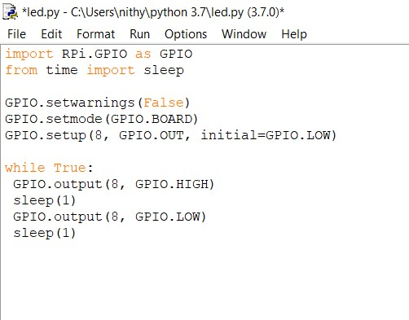

**Question-2:**

Write a python program for Traffic lights for Raspberry pi.

**Solution:**

from gpiozero

importButton,TrafficLights,Buzzer from time import sleep

buzzer = Buzzer(15) button = Button(21)

lights=TrafficLights(25,8,7)

while True:

button.wait_for_press()

buzzer.on() light.green.on() sleep(1) lights.amber.on()

sleep(1) lights.red.on() sleep(1) lights.off()

buzzer.off()

